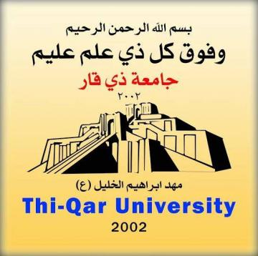
Ministry of Higher Education and
Scientific Research
Dhi Qar University
College of Physical Education
and Sports Science

Organizational Commitment and its Relation to Job Satisfaction for physical education teachers, according to the point of view of school principals in Dhi Qar Governorate

A thesis submitted by

Abbas Sabih Faraj

To the Council of the College of Physical Education and Sports Science - Dhi Qar University It is part of the requirements for a master’s degree in sports education

Supervised
Prof. Dr. A. Jassim Saad Jassim

2020 A.D 1442 A.H.

